1. Host a Ubuntu Virtual Machine using Oracle VM Virtual Box.

1. Set up Visual Studio code on Ubuntu VM.

1. Set up Python.

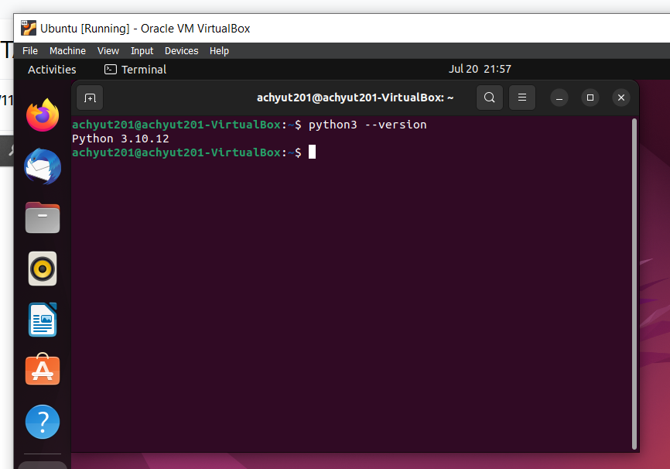

1. Clone Github repository

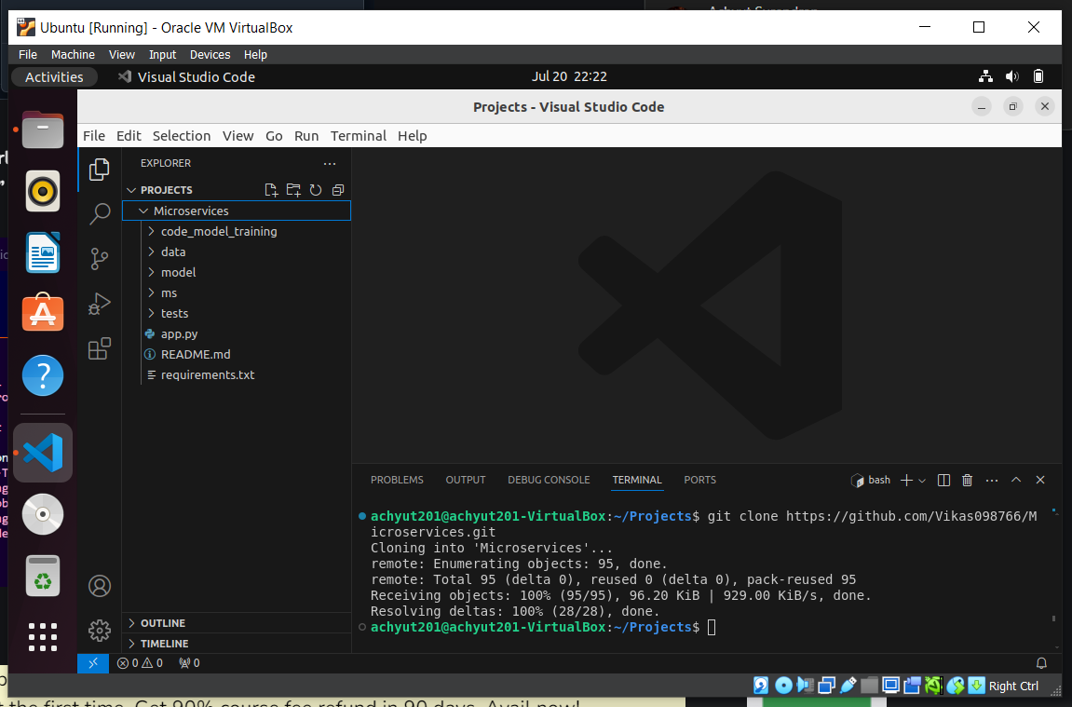

1. Create a Virtual Environment.

1. Install the dependencies from requirements.txt file.

Sudo pip3 install -r requirements.txt

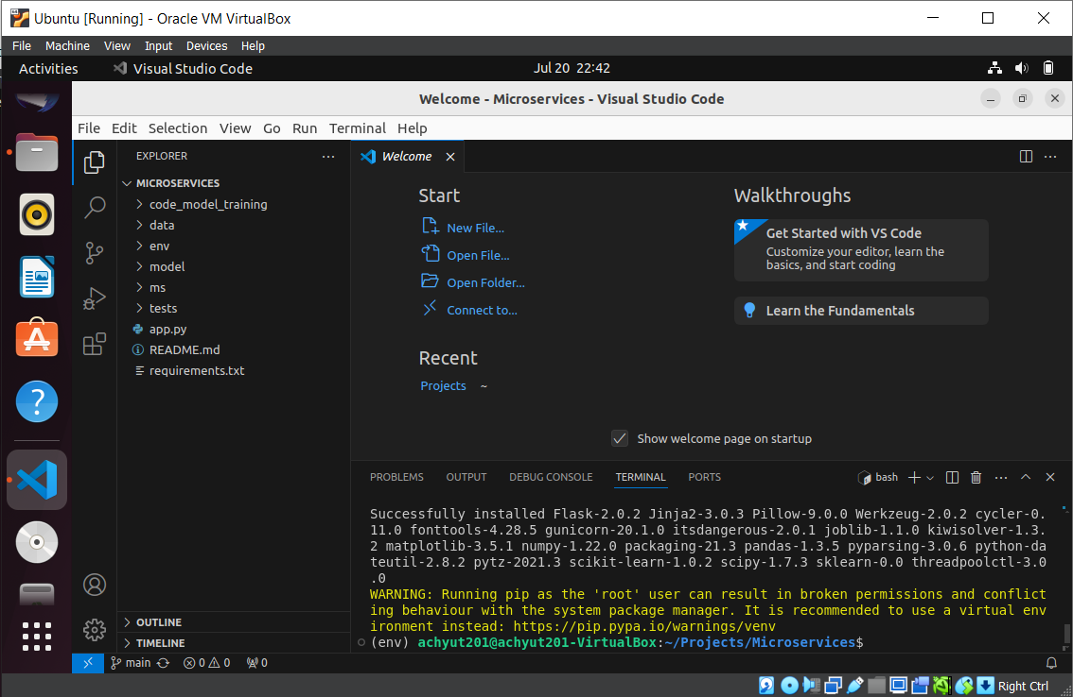

1. Train and save the model.

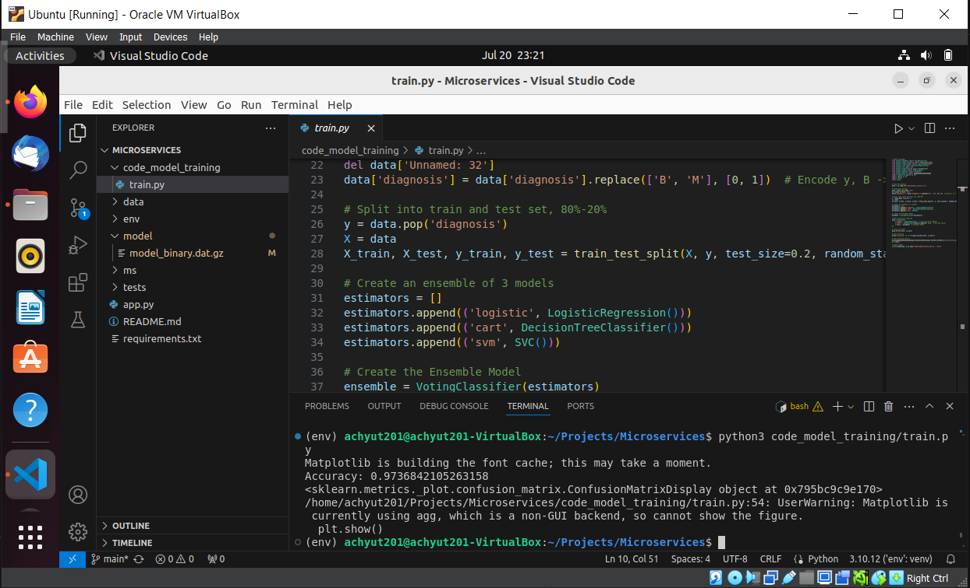

1. Test the Flask web application.

1. Test the application and make predictions using the example calls available in the folder /tests.

/predict

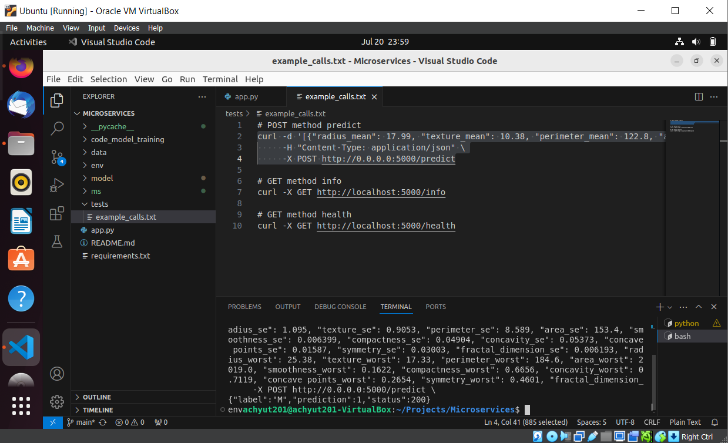

/info

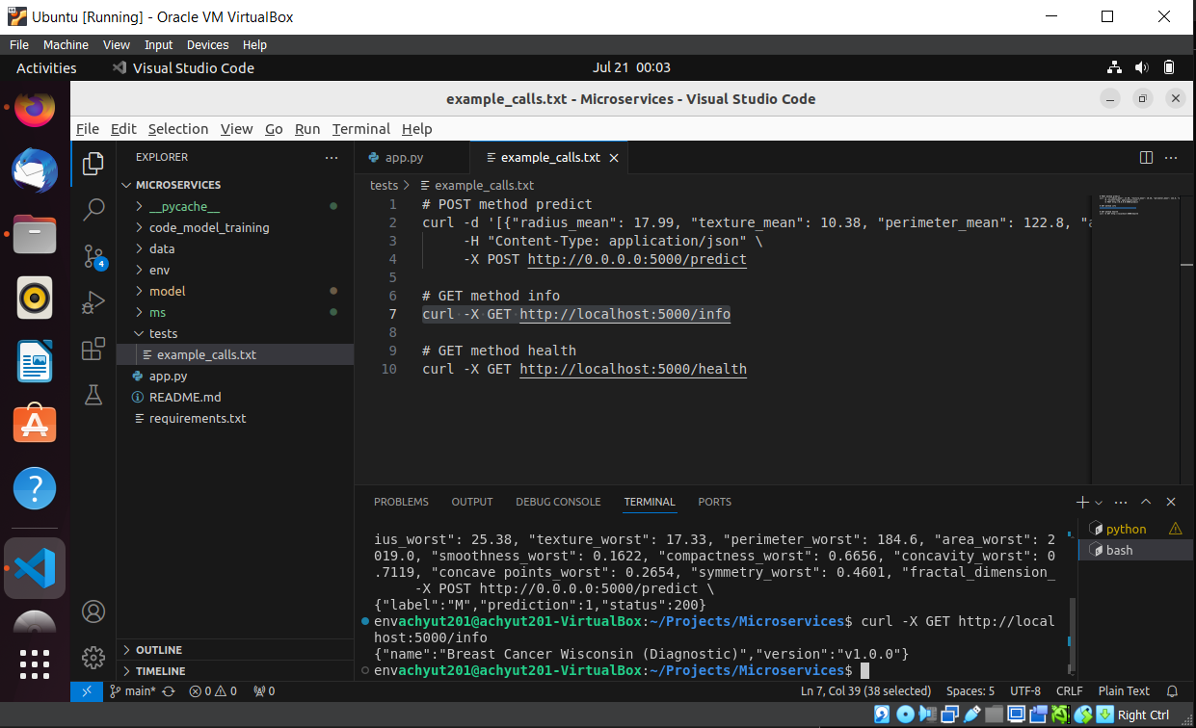

/health

1. Create a docker image containing everything needed to run the application.

Dockerfile

docker build -t pbm4docker .

Upload to docker hub

**achyut201/pbm4docker**

<https://hub.docker.com/r/achyut201/pbm4docker>

1. Run the containerized application as a prediction service and test it locally by passing some example calls and get the prediction.

docker run achyut201/pbm4docker

